**Improving FIR Laser Performance: Beam Profile Optimization and Stability Control**

**Abstract**

This study presents a systematic approach to improving FIR laser beam profiles through optimized mirror alignment, cavity length tuning, and real-time feedback control. A high-power CO₂ laser is used to pump the FIR laser, and its alignment with the waveguide axis is ensured using a HeNe reference laser. The sensitivity of FIR beam profiles to minor optical misalignments and thermal expansion is analyzed, demonstrating that even a 0.1° deviation significantly affects beam stability. A feedback control system, integrating a stepper motor and a power monitoring algorithm, is implemented to dynamically adjust cavity length and maintain optimal output power. Additionally, the impact of gas pressure on FIR laser stability is examined, with an optimal operating pressure identified to minimize intensity fluctuations. These implements contribute to more stable and reliable FIR laser diagnostics for studying electron turbulence in tokamak plasmas, ultimately supporting the physics study in fusion reactors.

**Introduction**

Electron turbulence is crucial in tokamak research because it significantly impacts the energy transport within the plasma, often contributing more than ion turbulence, and directly affects the overall efficiency of fusion reactions by causing significant heat loss through the rapid movement of electrons within the plasma1. Understanding and mitigating electron turbulence is key to achieving successful fusion in a tokamak device. The high-k scattering system is using a scattering process to measure small-scale fluctuations in plasma density. As the high-k wave launch into plasma and receive the scattering signal from special angle, the fluctuation intensity could be determined where the fluctuation wavelength satisfies the Bragg condition k = 2kisin ($θ_{s}/2$), here k is the fluctuation wavenumber, ki is the incident wavenumber, and θs is the scattering angle between the incident beam path and the receive beam path.

A 693 GHz poloidal high-k𝜃 scattering system, being jointly developed by the Princeton Plasma Physics Laboratory (PPPL) and the University of California at Davis (UC Davis), is targeted to study predicted ETG modes with improved k𝜃 range and resolution3. The source of the scattering system is an optically pumped far-infrared (FIR) using formic acid (HCOOH) vapor, pumped by a 150 W CO2 laser at the 9R20 line. The CO2 laser with 9.695um wavelength is focused in the FIR system and stimulated 693 GHz signal from HCOOH vapor6. The output laser of the FIR is then coupled into the waveguide and transmitted to the launch optics to minimize attenuation. The launch optics are used to adjust the launch beam angle to meet different measurement requirements4,5. The key point here is that the FIR beam should have a Gaussian profile for maximum coupling with the waveguide. The FIR system contains different types of mirrors for wave resonance, which mainly include copper mirrors with a hole in the center, mesh grids, and dielectric wafers. The beam profile is highly sensitive to the angle of the mirrors in the FIR system; even a slight change of 0.1° can significantly alter the beam shape. However, the adjustment of mirrors in the FIR system is rarely discussed in the literature, and details about FIR beam quality are seldom provided. In this paper, we present a method for mirror adjustment and highlight key points for beam stability and beam profile improvement.

**The layout of CO2 and FIR system**

* **CO2 system**

The schematic of CO2 laser is illustrated in Fig.1. There are two separated laser cavity waveguide tube, each tube has its own power supply with cathode voltage at around -15 kV and anode voltage at 0 V. During the discharge, the high voltage will break through the CO2 gas and driven the plasma current at around 40 mA. The energy input excites the CO2 gas to high energy level and emit the Infrared radiation through quantum cascade transition7-8. The radiation polarization will be selected through Brewster window as the P-polarization have 100% transmittance of the Brewster window while the S-polarization will be reflected and absorbed by absorbing material. The wavelength will be selected by the diffraction grating angle through backward reflection. As the radiation with selected polarization and wavelength reflected from the diffraction grating reflected through two mirrors into the other tube, the next boundary condition will take effect which is named as output coupler. The output coupler is the mirror that substrate is ZnSe for partial reflection of the CO2 laser about 60%2. The laser reflected from the output coupler and diffraction grating will continuously stimulate additional laser generation. When the cavity length between the diffraction grating and the output coupler meets the resonance condition, the laser will achieve maximum output power. To adjust the cavity length, the output coupler is connected to a piezoelectric crystal, which could alter the crystal dimension by DC voltage of 0 to 1500 V within 15um, while the wavelength of CO2 laser is about 9.5um.

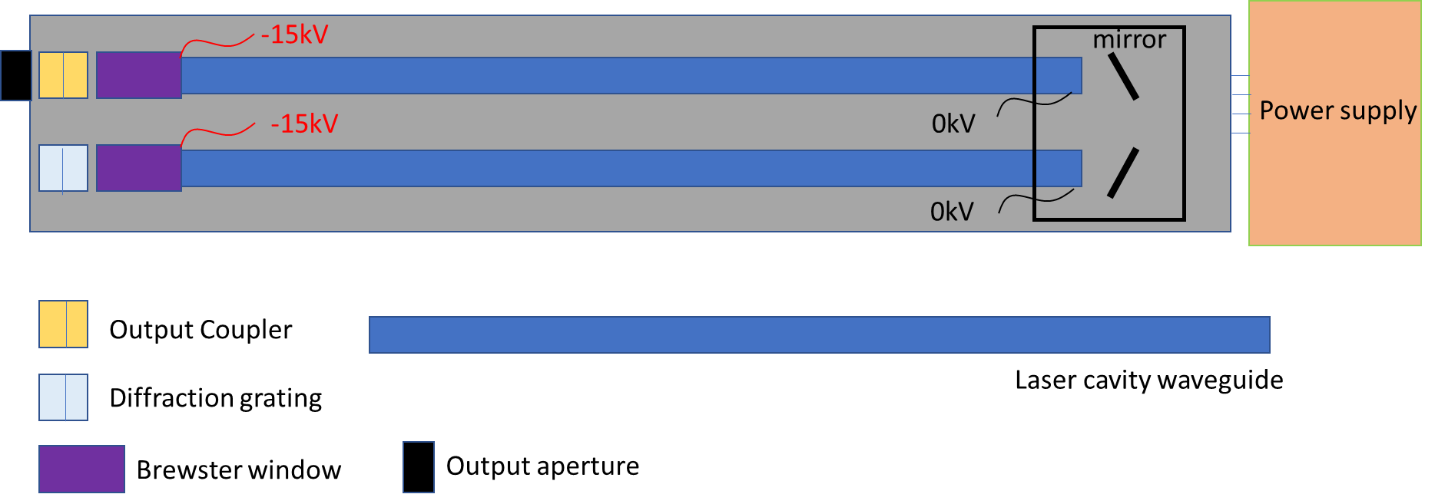

Figure .The main components of CO2 laser

Figure.2 illustrates the Brewster window and diffraction grating on PL-6 CO2 laser system. The diffraction grating can adjust the tilt angle through adjustment knob, with each wavelength corresponding to a specific code number for grating adjustment. Figure.3 demonstrate the operation panel of CO2 laser, which include the piezo adjustment, gas flow control, gas shutoff knob, cooling water circulation pipeline, gas pumping tube and gas inlet port. The piezo translator is used to adjust the cavity length for maximum output power. The gas flow control system, shown in Figure 3(a), regulates the gas flow velocity. The vacuum pump, depicted in Figure 3(b), is equipped with a pressure monitor to measure the gas pressure. The laser system is powered by two power supplies from Edinburgh Instruments, each operating at 40 mA and 15 kV under normal conditions. In addition, a cooling circulation system is incorporated to efficiently dissipate heat from the laser system to the external environment.

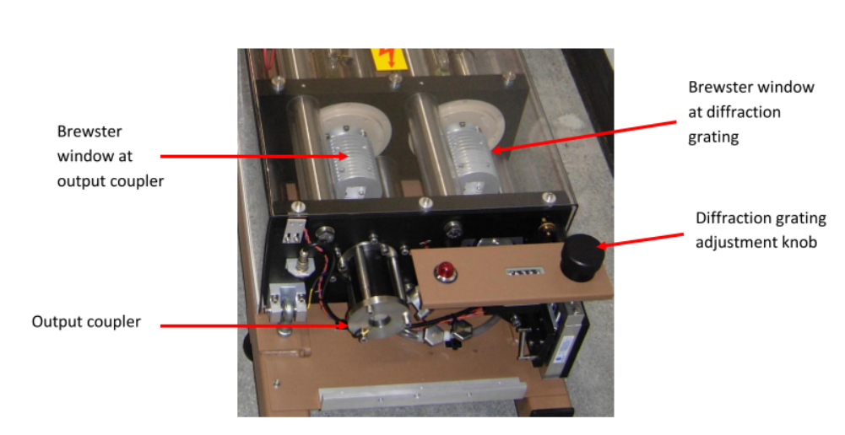

Figure . Output end of the PL-6 laser. The Brewster windows, output coupler, and diffraction grating adjustment knob are labeled 2.

Figure .(a) Laser head control panel. All laser hook-ups are made through this panel including, electrical, gas, vacuum, and water. The Gas shut off and flow control are located at the upper right. The PZT controls at the upper left. (b) vacuum pump with pressure monitor

* **FIR system**

The schematic of the FIR system is shown in Fig.4 . The system consists of a rear mirror, a dielectric waveguide tube, a front mirror, and a metallic mesh. The rear mirror is a copper mirror coated with gold, featuring a central hole to allow the CO₂ laser to pass through. The front mirror is a dielectric-coated silicon wafer, designed to provide high FIR transmission (98%) and high CO₂ laser reflection (99%)2. The metallic mesh has a density of 300 lines per inch (lpi), with 20% transmission and 80% reflection for FIR radiation at a 432 μm wavelength9.

The front mirror and metallic mesh are mounted on a stage that can be adjusted along the waveguide axis, driven by a stepper motor. The CO₂ laser oscillates between the front and rear mirrors, while the FIR laser oscillates between the metallic mesh and the rear mirror. By adjusting the cavity length between the metallic mesh and the rear mirror, the output power can be optimized to its maximum value.

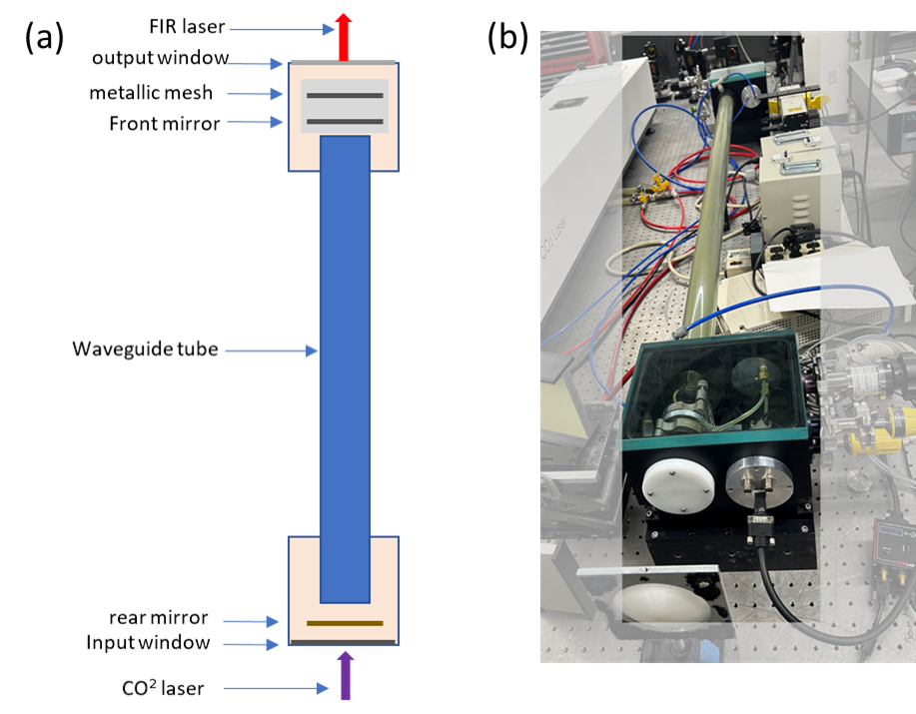

Figure .Overview of FIR system formic acid laser (a) schematic layout of FIR laser system. (b) Real picture of FIR laser system.

* **The combined system**

As shown in Figure 5, the laser system consists of a CO₂ laser system, a FIR laser system with a focusing lens, and a reflector mirror, which facilitates coupling the CO₂ laser into the FIR system. The CO₂ laser beam has a diameter of approximately 11 mm at the output coupler, while the FIR input window has a diameter of 10 mm. Therefore, a focusing lens with focal length of approximately 1 m is necessary to direct the CO₂ beam into the FIR system. The CO₂ beam at focus point is located between the input window and the rear mirror as shown in Figure 4(a), where its diameter is reduced to about 3 mm. The CO2 laser shinning into the FIR system, The Formic acid gas in the FIR laser waveguide tube will be stimulated by CO2 laser and emit the FIR laser continuously.

However, the FIR laser beam profile and intensity are strongly influenced by the optical setup and alignment. Even a minor misalignment of 0.1° can result in a significant alteration of the beam profile. Therefore, precise alignment is crucial to ensuring optimal beam quality and intensity.

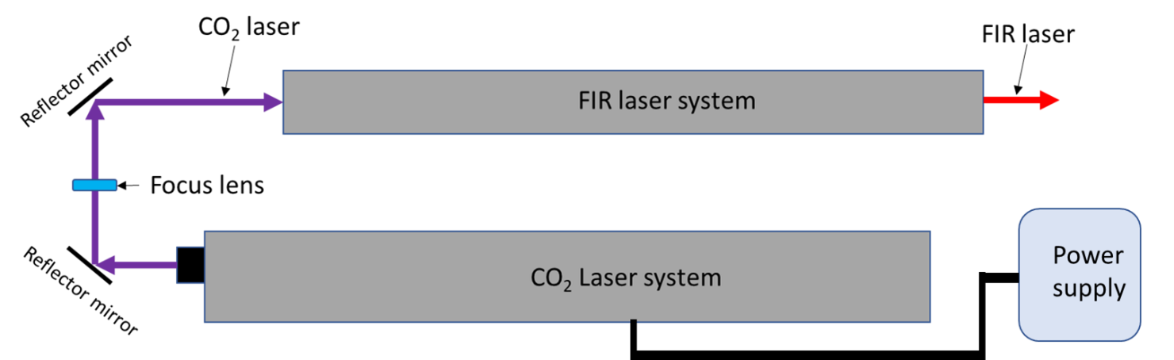

Figure . The overview of the laser system setup

**Optical alignment setup**

To maximize the FIR laser's output power and ensure an optimal beam profile, the CO₂ laser should be precisely aligned with the FIR laser waveguide axis. Additionally, the mirrors in the FIR laser system must be perpendicular to the waveguide axis to facilitate multiple reflections and support the dominant FIR wave mode, EH11​, which results in a Gaussian beam profile at the output.

(1). CO2 laser alignment

The system alignment is setup as shown in Figure 6. Since the CO₂ laser is invisible to the human eye, a HeNe laser is used to align the CO₂ laser with the FIR laser system. The HeNe laser is positioned behind the output of the FIR laser system, approximately 4.8 m away. To allow the visible laser to pass through unobstructed, the metallic mesh, front mirror, and rear mirror are temporarily removed. Beside this, the HeNe laser is finely adjusted to ensure that the beam passes through the center of both the input and output windows.

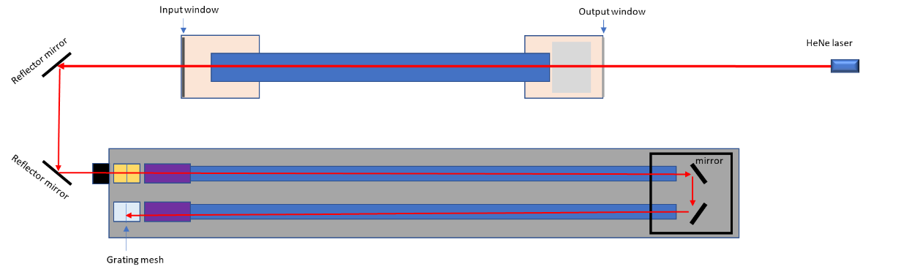 The visible laser beam is then reflected into the CO₂ laser output window using two reflector mirrors. If the beam does not pass through the center of the CO₂ laser output window, the CO₂ laser system should be repositioned to align the window center with the visible laser. After removing the protective cage of the CO₂ laser system, the laser footprint is examined on the grating mesh. If the footprint is not centered on the grating mesh, the CO₂ laser system position should be carefully adjusted to ensure the laser hitting on the center of the grating mesh. Then both the FIR system and the CO₂ system are aligned using a HeNe laser, ensuring that the CO₂ laser is co-axial with the FIR waveguide tube. This alignment maximizes the CO₂ laser's bounce time within the FIR waveguide tube, thereby enhancing absorption and energy transfer to the FIR laser.

Figure . CO2 laser alignment setup

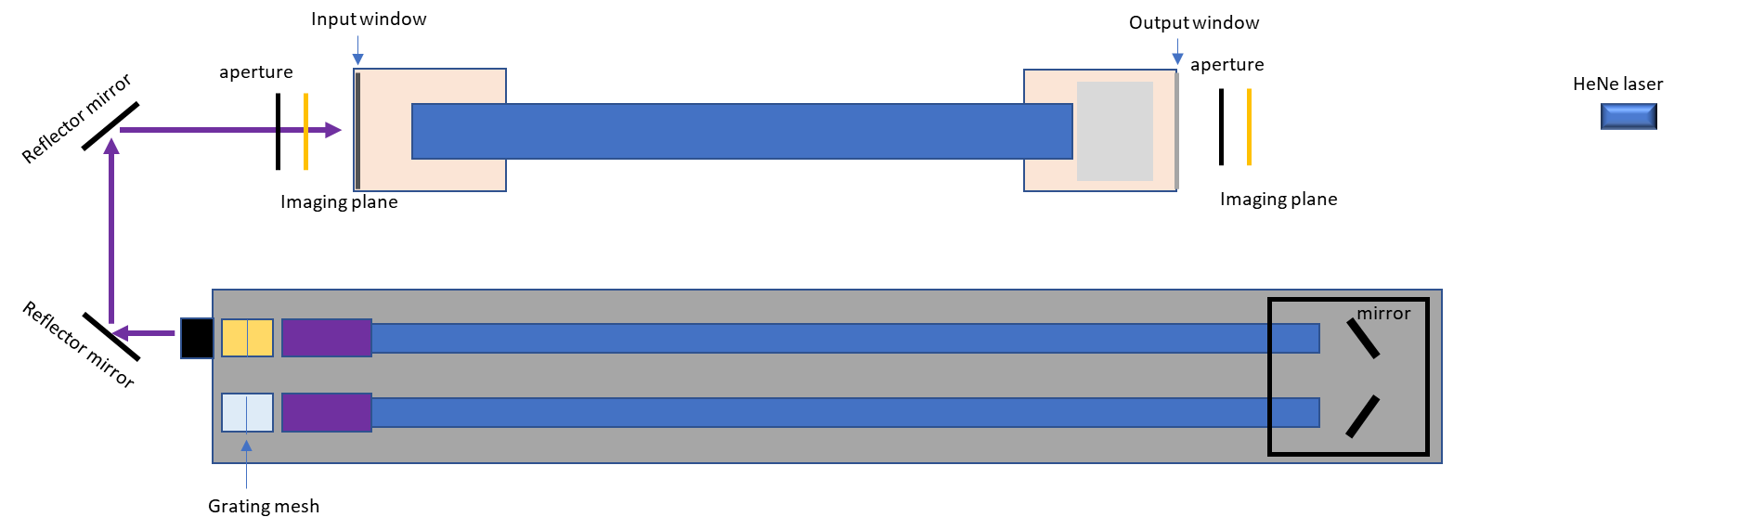

Figure .CO2 laser alignment benchmark

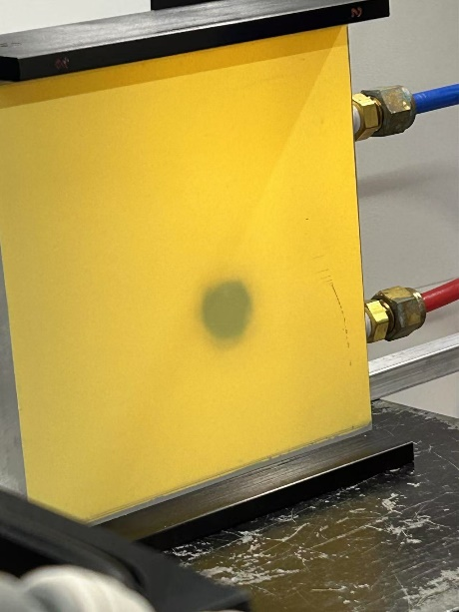

Figure .The imaging of the CO2 laser beam profile

To verify the alignment of the CO₂ laser with the FIR system, two adjustable apertures are positioned in front of the input window and behind the output window of the FIR laser system. The center of each aperture is aligned with the axis of the HeNe laser path. An imaging plane is used to illustrate the CO₂ beam profile as shown in Fig. 8.

The alignment procedure is as follows: first, the apertures are fully opened, and the CO₂ laser is turned on to check whether the beam profile aligns with the HeNe laser optical path at both positions. The method involves gradually reducing the aperture size and examining the clipped beam profile. If the beam profile is symmetrically clipped, the CO₂ beam is aligned with the main optical axis. If asymmetry is observed, the beam is shifted toward the side where more clipping occurs. By checking the beam position at both locations and making slight adjustments to the mirror angle, the CO₂ beam can be aligned with the axis of the visible laser.

(2) Mirror alignment in the FIR laser system

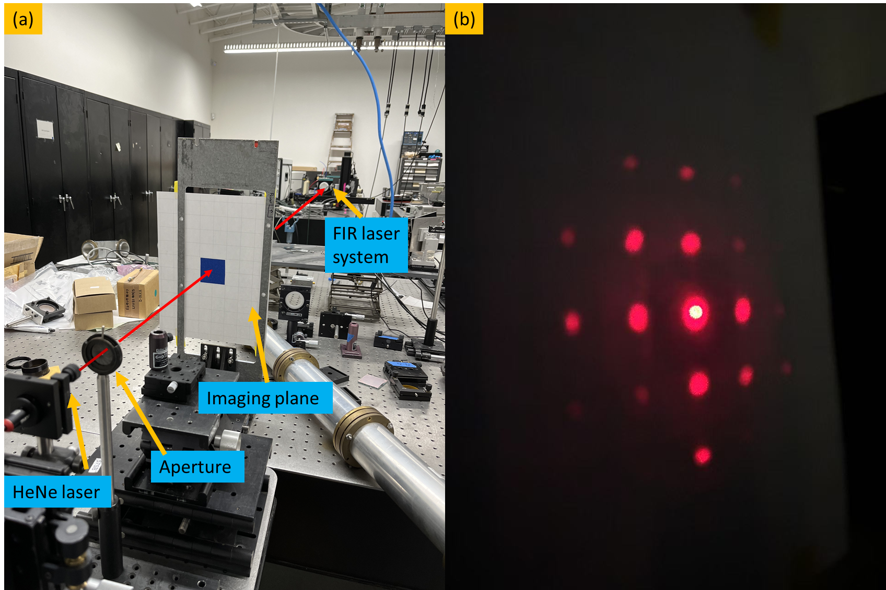

Figure .(a) FIR laser system alignment setup. (b) diffraction pattern on imaging plane from metallic mesh

The mirror inside the FIR laser system is aligned based on the reflection of the HeNe laser. As shown in Fig.9(a), an imaging plane with a small aperture is positioned in front of the HeNe laser to allow the reference beam to pass through. The distance between the imaging plane and the output window is approximately 3.5 m, ensuring high-precision angular alignment in 0.1 degree.

The alignment procedure begins with the installation of the rear mirror, which contains a central aperture to transmit the CO₂ laser. The rear mirror is carefully positioned so that its center coincides with the HeNe laser beam. As the diameter of the HeNe laser beam is slightly larger than that of the aperture, Fraunhofer diffraction is observed on the imaging plane. By adjusting the rear mirror to align the central diffraction pattern with the aperture on the imaging plane, it can be ensured that the rear mirror is perpendicular to the optical axis.

Similarly, the front mirror reflects the HeNe laser, and its alignment is optimized by adjusting its angle until the reflected beam precisely overlaps with the central aperture on the imaging plane. For the metallic mesh, alignment is achieved by modifying its angle until the zero-order diffraction pattern coincides with the central aperture on the imaging plane, as shown in Fig.9 (b).

* **the FIR laser adjustment and measurement**

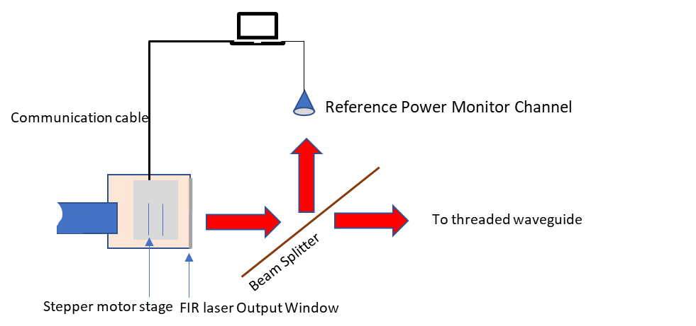

Figure .FIR laser cavity adjustment setup

Since the beam intensity is highly sensitive to the cavity length, maximum output power can only be achieved under resonance conditions. Therefore, cavity adjustment is necessary during operation. Figure. 10 illustrates the cavity adjustment setup for optimizing beam power. A beam splitter with a 10:1 intensity ratio is used, where the reference channel utilizes the lower-intensity portion to monitor power variations, while the main power is used for diagnostics. A computer analyzes the power evolution and controls the stepper motor stage, which adjusts the cavity length accordingly.

As shown in Fig.11, the FIR laser intensity varies with the scanning of the cavity length. The peak-to-peak distance is approximately 216 µm, which is about half of the wavelength (432.6 µm). Furthermore, when zooming in on a single peak structure, small fluctuations are observed with a periodicity close to a quarter of the CO₂ laser wavelength (9.5 µm).

The difference between the FIR and CO₂ laser resonance structures originates from their distinct boundary conditions. For the FIR laser, the resonant space is defined between the metallic mesh and the rear mirror, both of which can be approximated as perfect electric conductors. This results in the boundary condition ${k_{1}d}_{1}=nπ$, leading to a resonance spacing of $Δd_{1}=\frac{π}{k}=\frac{λ_{1}}{2}$, where k1​ is the wavevector of the FIR laser, n is integer number, $λ_{1}$ represents the wavelength of FIR and d1 is the distance between the boundaries.

In contrast, for the CO₂ laser, the resonant space is between the front and rear mirrors, with the front mirror being a dielectric wafer. This modifies the resonance condition to $2{k_{2}d}_{2}+ϕ=nπ$, where d2 is the resonant cavity length, k2 is the wavevector of the CO₂ laser, and $ϕ$ accounts for the phase shift upon reflection from the front mirror surface. Consequently, the resonance spacing is given by $Δd_{2}=\frac{λ_{2}}{4}$, where $λ_{2}$ represents the wavelength of CO2 laser, which agrees well with the experimental results.

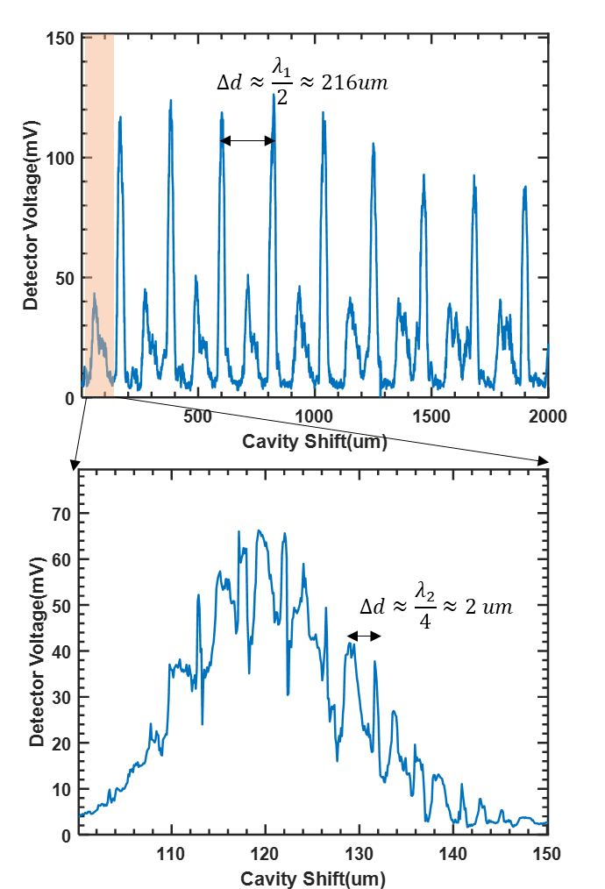

Figure .FIR output intensity with cavity shift measured under Formic acid gas pressure around 150 mTorr

**Intensity instability caused by thermal expanding**

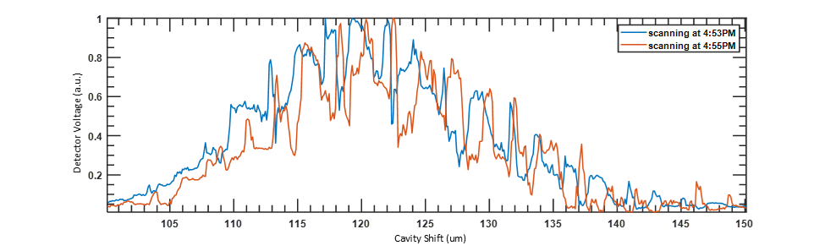

Figure . FIR intensity structure with cavity shift at two different times.

Due to thermal expansion, the FIR intensity structure gradually shifts right over time, in the direction that compensates the thermal expansion. If the cavity position remains fixed, the intensity fluctuates by approximately 40% within the 2 minutes before the system reaches thermal stability. It typically takes about 2 hours to achieve full thermal stability. This fluctuation introduces uncertainty in distinguishing whether the observed variations originate from plasma dynamics or the system itself, reducing the accuracy of high-k spectrum evolution diagnostics.

**Method to keep intensity stability**

1. increase the HCOOH gas pressure

Since the strong fluctuation is caused by CO₂ laser resonance, one way to mitigate it is by increasing the formic acid gas (HCOOH) pressure. Higher HCOOH pressure enhances CO₂ laser absorption, reducing the resonance effect and resulting in a smoother FIR intensity structure. As shown in Fig.13, once the pressure exceeds 190 mTorr, the fluctuation becomes significantly smaller. However, as the pressure increases, the maximum intensity also decreases. To balance intensity and fluctuation, we choose P around 221 mTorr as the optimal pressure.

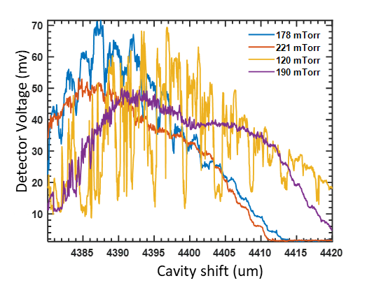

Figure .Scanning Cavity under different gas pressure

1. setup the feedback control system

The main resonance structure of the FIR laser also shifts to the right due to thermal expansion, leading to an intensity drop if the cavity remains stationary. To address this, a feedback control system is implemented for automatic cavity optimization. The system continuously monitors the power of FIR, and once the intensity drops to 80% of its original value, it drives the stepper motor to adjust the position of the mesh and front mirror, shifting the cavity to the right to find the optimal position. Controlled by LabVIEW, the system integrates the power monitor, a Thorlabs stepper motor, and a host computer. It operates automatically to maintain the cavity at its optimal position, with each adjustment process taking approximately 10 seconds. The maximum power of FIR is around 40mW to 50 mW, which is measured by absolute power meter.

**Beam profile measurement**

The beam profile is measured using a self-developed auto-scanning stage system. This system includes a power detector with a window diameter of approximately 5 mm and a three-stepper motor stage that drives the optical stage in the X, Y directions. As shown in Fig.14, two power monitors are used—one for power measurement and the other for reference power measurement at a fixed position. The real beam profile would be demonstrated as the distribution of Pscan/Pref, where the $P{}_{scan}$ refers to the scanning channel power at each point while the Pref refers to the power on reference channel at each point. This approach helps compensate for power fluctuations during the measurement. A power detector with a chopper, positioned in front of the FIR window at approximately 300 mm, measures a 20 mm × 20 mm range in the X-Y direction with a step size of 2 mm.

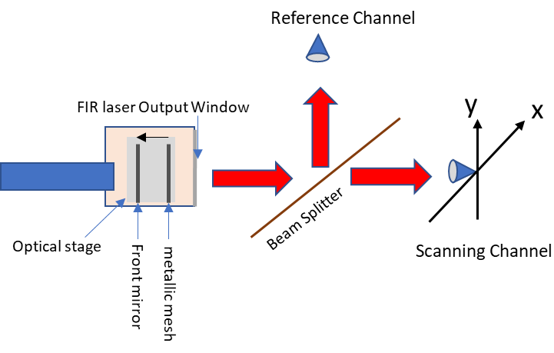

Figure . Beam profile measurement setup

The beam profile appears as shown in Fig.15 when all mirrors are well aligned. However, it is highly sensitive to the metallic mesh angle—even a deviation of 0.1° can result in a completely different beam profile, as demonstrated in Fig. 16 and 17 . Here, zCavity represents the cavity shift along the optical axis. Each time the mesh angle is adjusted, the cavity must be reset to its optimal position before measuring the beam profile. The diffraction pattern observed on the imaging plane can be used to evaluate the metallic mesh angle. Given that the distance from the imaging plane to the mesh is approximately 3 meters, a displacement of about 3 mm from the zero-order spot to the center hole (which allows the reference laser to pass through) corresponds to a mesh angle deviation of roughly 0.06° relative to the reference laser. However, the beam profile varies significantly depending on the direction of this deviation, highlighting the extreme sensitivity of the mesh angle to alignment adjustments. Consequently, aligning the mesh requires meticulous precision and, at times, even a bit of luck. The most practical solution is to position the mesh outside the vacuum chamber, which could make laser alignment much easier.

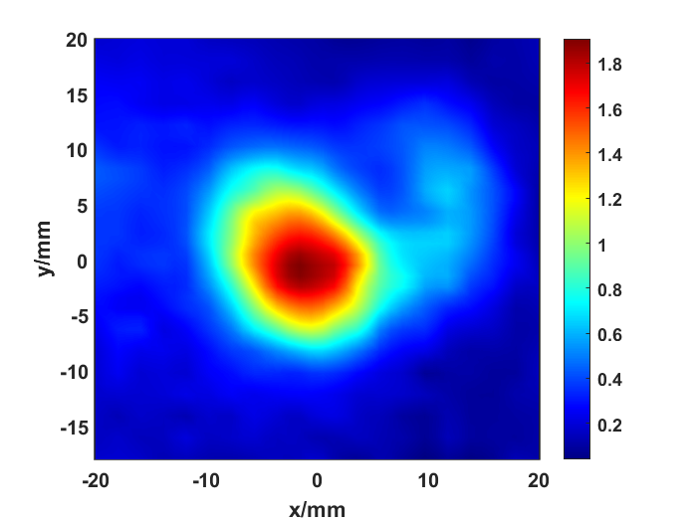

Figure .FIR beam profile

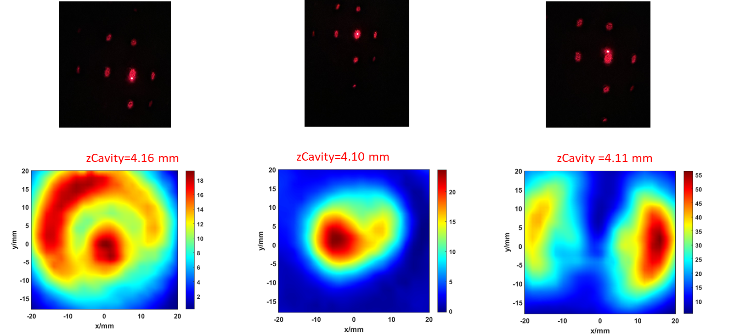

Figure .Beam profile for zero-order diffraction pattern at Upper, near center and below of the center.

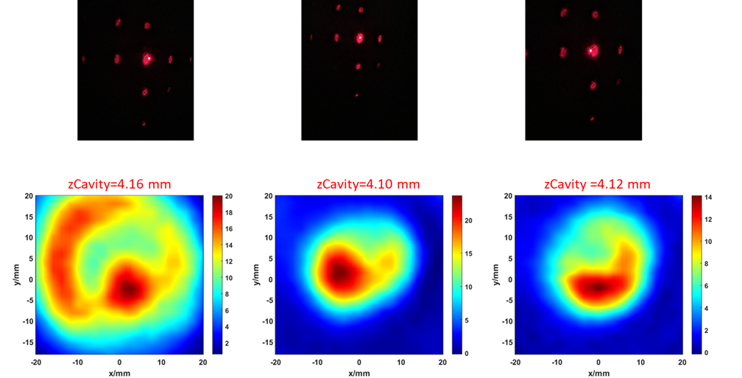

Figure Beam profile for zero-order diffraction pattern at left, center and right of the center

**Summary**

This paper explores the optimization of beam profiles in far-infrared (FIR) laser systems for high-k scattering diagnostics in tokamak plasmas. The study emphasizes the critical role of precise optical alignment, thermal stability, and feedback control in maintaining optimal FIR laser performance. A detailed methodology for mirror alignment, cavity length optimization, and beam profile measurement is presented, offering practical approaches to enhance beam stability and quality. The results highlight the significant sensitivity of beam profiles to minor misalignments and thermal expansion, which can lead to fluctuations in intensity and diagnostic inaccuracies. To address these challenges, a feedback control system is implemented to maintain optimal cavity conditions, and the impact of gas pressure variations on laser stability is examined. Additionally, the study proposes an improved optical configuration by placing the metallic mesh outside the vacuum chamber to simplify alignment and improve beam quality. These advancements contribute to more reliable FIR laser systems for diagnosing electron turbulence in tokamak plasmas, ultimately supporting the development of efficient fusion reactors. Future work will focus on refining alignment techniques and further stabilizing the laser system against thermal variations.

**Reference:**

1.Qi, Lei. "Energy transfer of trapped electron turbulence in tokamak fusion plasmas." *Scientific Reports* 12.1 (2022): 5042.

2.Barchfeld, Robert Adam. “*Development of Laser Based Plasma Diagnostics for Fusion Research on NSTX-U”*. 2017.

3.Domier, C. W. “A poloidal high-k scattering system for NSTX-U”. *Journal of Instrumentation* 17.01 (2022): C01018.

4: Liu, Xianzi, et al. "Quasi-optical beam tracing module development for millimeter-wave high-wavenumber collective scattering on the NSTX-U and EAST tokamaks." Fusion Engineering and Design 212 (2025): 114826.

5.Liu, Xianzi, et al. "The National Spherical Torus Experiment-Upgrade poloidal high-k scattering system pitch angle design modifications." *Review of Scientific Instruments* 93.10 (2022).

6. Dangoisse, D., and P. Glorieux. "The optically pumped formic acid laser." *Reviews of Infrared and Millimeter Waves: Volume 2 Optically Pumped Far-Infared Laser*. Boston, MA: Springer US, 1984. 429-465.

7.Jacobsson, Stellan. "Optically pumped far infrared lasers." *Infrared physics* 29.5 (1989): 853-874.

8. Mukhopadhyay, Indranath, and Shyam Singh. "Optically pumped far infrared molecular lasers: molecular and application aspects." *Spectrochimica Acta Part A: Molecular and Biomolecular Spectroscopy* 54.3 (1998): 395-410.

9. Deng, Bihe, et al. "Innovative high-gain optically pumped far-infrared laser." *Applied Optics* 55.21 (2016): 5580-5584.